Approach:

The base game model is implemented in C++, and creates an interactive ASCII representation of the 6x7 Connect 4 game board. Two players are created, for testing purposes both players are initially completely randomized AI which simply choose a random column number 1-7 to place their piece in to. As soon as a player gets 4 pieces in a row, either across a row, up a column, or diagonally, they win the game and the game ends. A win count variable is kept for each player in order to track overall win percentage for analysis of results. Internally, the state of the game board is converted a one dimensional array where a 0 represents a blank space, and 1 and 2 represent the respective player pieces. This array is used for compatibility with Matlab functions and is passed to our learning algorithm to compute various move possibilities.

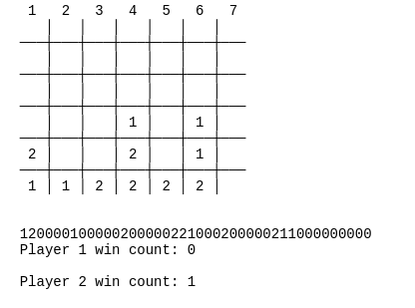

Sample final output of AI vs. AI game run, with board state converted to one dimensional array, and win counter.

Results:  
  
During each game iteration, the starting player is randomly chosen, for  
fairness. Variables store player 1 and player 2 win counts. The command line  
argument indicates the number of games to play. As expected, the base case of  
two completely random AI players is a near perfect 50/50 split.

Sample run of two completely random AI players:

$ ./con4 10000  
  
Player 1 win count: 4992  
  
Player 2 win count: 5008